

**BBIT PUBLIC SCHOOL**

**NAME: DEBJIT KUNDU**

**CLASS: XI**

**SECTION: A**

**STREAM: SCIENCE**

**SUBJECT: COMPUTER SCIENCE**

**PROJECT CUM PRACTICAL FILE**

**ACKNOWLEDGEMENT**

*I would like to express my special thanks of gratitude to my computer teacher Rochisnu sir as well as our principal mam who gave us this golden opportunity to do this wonderful project which also helped me in doing a lot of research and I came up to know about so many things. I am really thankful to them.*

*In addition, I would also like to thanks my parents and friends who helped me in finishing this project on limited time.*

**INDEX**

|  |  |  |  |  |
| --- | --- | --- | --- | --- |
| SL.NO. | TOPIC | DATE | PAGE NO. | REMARKS |
| 1 | *perfect number* | *30.09.2021* | *4* |  |
| 2 | *Prime number up to limit* | *30.09.2021* | *5* |  |
| 3 | *Percentage and grade* | *30.09.2021* | *6* |  |
| 4 | *Sum of series 1+x/1..+xn/n!* | *30.09.2021* | *7* |  |
| 5 | *Count alphabets, digits, spaces, other characters etc.* | *30.09.2021* | *8* |  |
| 6 | *Capitalize first letter of words* | *30.09.2021* | *9* |  |
| 7 | *Checking format of number* | *30.09.2021* | *10* |  |
| 8 | *Final price and GST* | *30.09.2021* | *11-12* |  |
| 9 | *Triangular pattern with @* | *30.09.2021* | *13* |  |
| 10 | *Triangular pattern with alphabets* | *30.09.2021* | *14* |  |
| 11 | *Reverse Floyd’s triangle* | *30.09.2021* | *15* |  |
| 12 | *Binary to decimal and octal* | *30.09.2021* | *16* |  |
| 13 | *Print even numbers from 1 to 100* | *30.09.2021* | *17* |  |
| 14 | *Factorial of a number using loop.* | *30.09.2021* | *18* |  |
| 15 | *Multiplication table of a number* | *30.09.2021* | *19* |  |

**PROGRAM 1:** WAP in python to find out whether it is a perfect number or not.

INPUT:

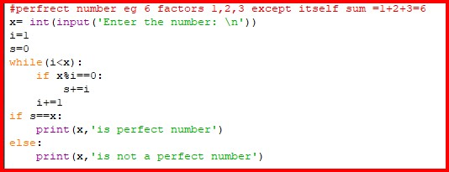

OUTPUT:

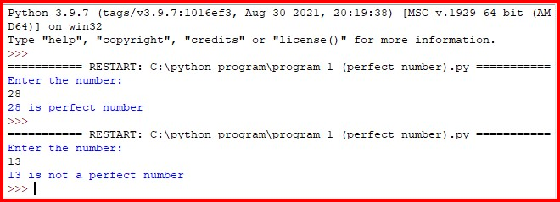

**PROGRAM 2:** WAP in python to display prime number up to a certain limit.

INPUT:

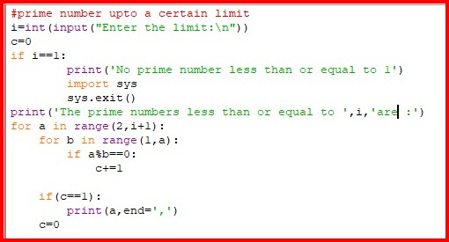

OUTPUT:

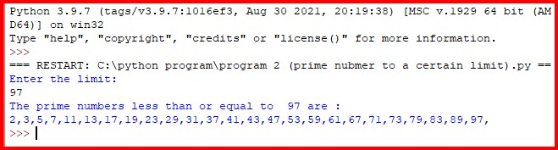

**PROGRAM 3:** WAP in python to accept percentage of a student and display the grade accordingly.

INPUT:

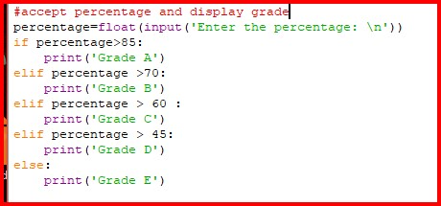

OUTPUT:

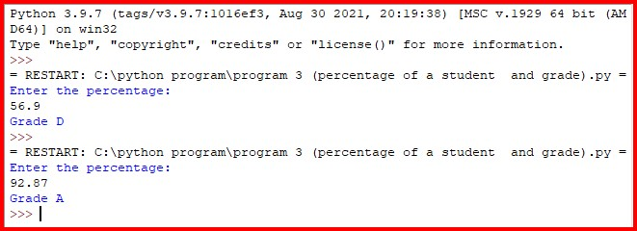

**PROGRAM 4:** WAP in python to print the sum of the series 1+x1/1! +x2/2!...xn/n!

INPUT:

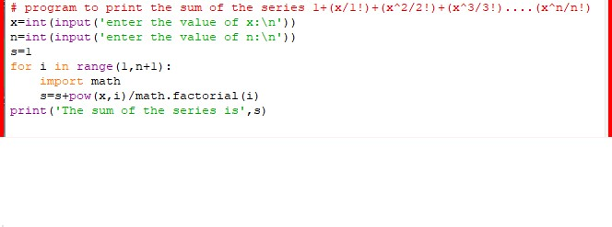

OUTPUT:

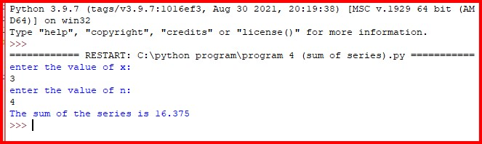

**PROGRAM 5:** WAP in python that counts the number of alphabets, numbers, uppercase letters, lowercase letters, spaces and other character.

INPUT:

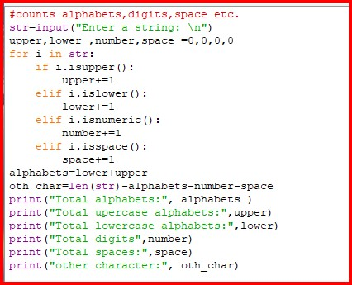

OUTPUT:

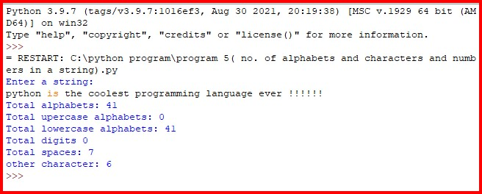

**PROGRAM 6:** WAP in python to accept a string a string and return a string with first letter of each word capitalized.

INPUT:

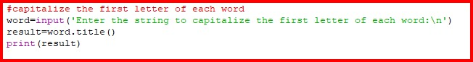

OUTPUT:

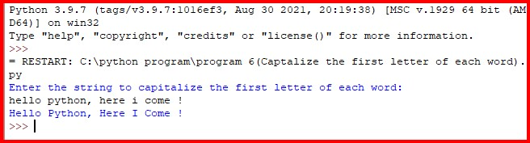

**PROGRAM 7:** ABC dialing networks is accompany that deals in maintaining phone numbers of customers globally. WAP in python that prompts for a phone number of 10 digits with two dashes is a valid input. Display if the phone number is in the valid format or is invalid.

INPUT:

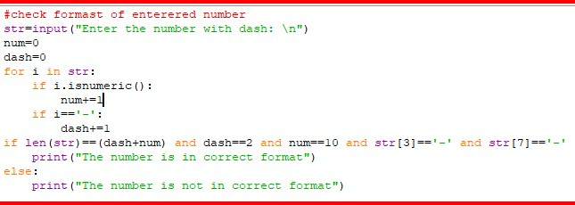

OUTPUT:

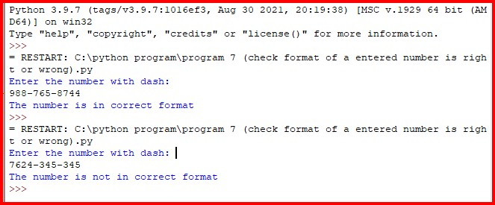

**PROGRAM 8:** Redwood shop deals in apparels and footwear’s. WAP in python to calculate total selling price after levying of GST. Follow the given table:

|  |  |  |
| --- | --- | --- |
| Items | Cost | Rate of CGST/SGST |
| Footwear | <=500 | 5% |
| Footwear | >500 | 18% |
| Apparels | <=1000 | 5% |
| Apparels | >1000 | 12% |

INPUT:

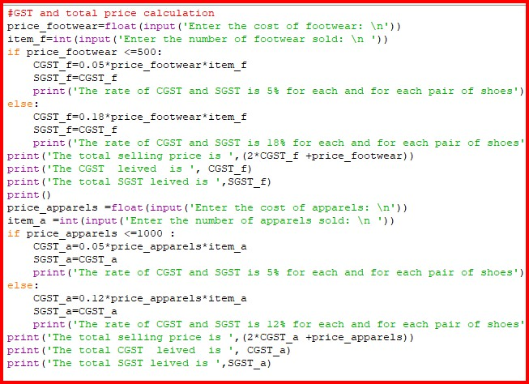

OUTPUT:

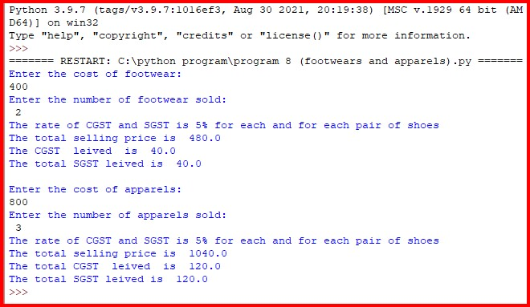

**PROGRAM 9:**  WAP in python to print the pattern.

@

@@

@@@

@@@@

@@@@@

@@@@@@

INPUT:

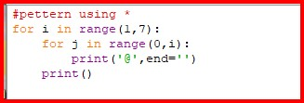

OUTPUT:

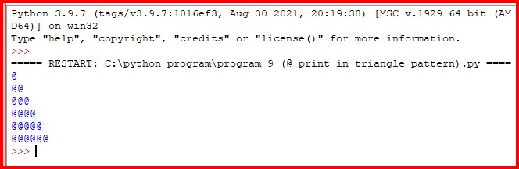

**PROGRAM 10:** WAP in python to print the pattern.

A

B C

D E F

G H I J

K L M N O

INPUT:

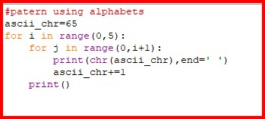

OUTPUT:

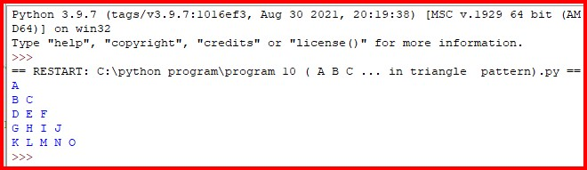

**PROGRAM 11:** WAP in python to accept the number of rows and print the reverse Floyd triangle.

INPUT:

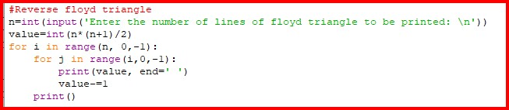

OUPTPUT:

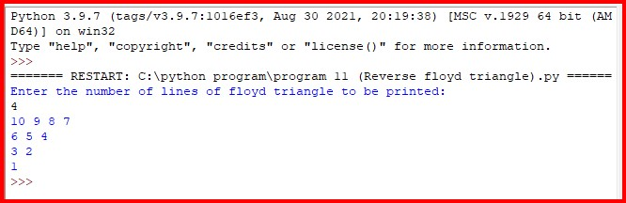

**PROGRAM 12:** WAP in python to convert binary to decimal and octal.

INPUT:

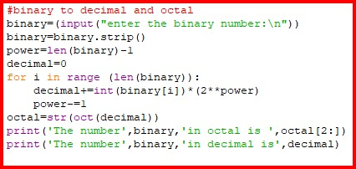

OUTPUT:

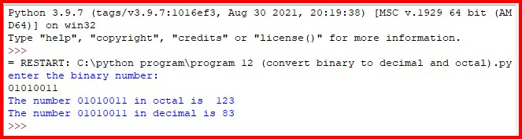

**PROGRAM 13:** WAP in python to print even numbers from 1 to 100.

INPUT:

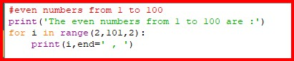

OUTPUT:

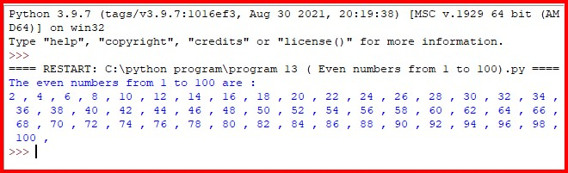

**PROGRAM 14:** WAP in python to print the factorial of a number using loop.

INPUT:

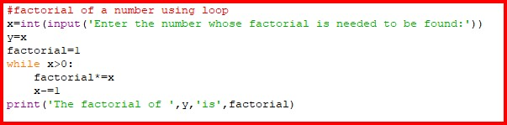

OUTPUT:

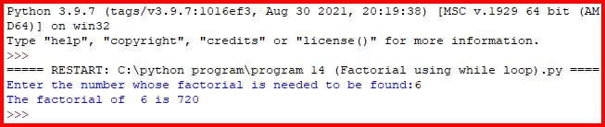

**PROGRAM 15:** WAP to print he multiplication table of a number up to a limit.

INPUT:

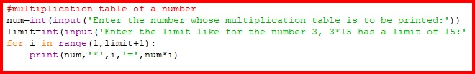

OUTPUT:

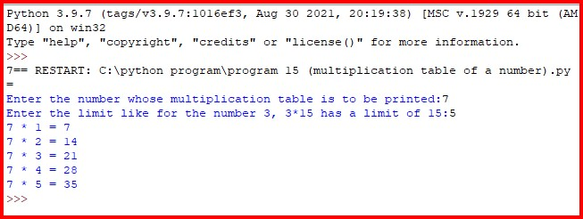

Internal Examiner External Examiner